MYSQL WITH PYTHON

QUES :- Define a function named as db to create a new database named as school.

PROGRAM :-

import mysql.connector as c
con=c.connect(host='localhost',user='root',password='',charset='utf8')
if con.is_connected():
print('succesfully connected..........')
cursor=con.cursor()

def db():
que='create database if not exists school'
cursor.execute(que)
print('Database created...')
db()
OUTPUT:-

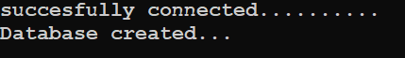
QUES:- Define a function table() to create a new table named as class_12 with attributes Name, Class, Roll_no,section and Gender in database named as school.

PROGRAMM :-

import mysql.connector as c
con=c.connect(host='localhost',user='root',password='',database='school',charset='utf8')
if con.is_connected():
print('succesfully connected..........')
cursor=con.cursor()

def tb():
cursor.execute('create table if not exists class_12(Rno int primary key,Name varchar(15),Class int,Sec varchar(10),Gender varchar(15))')
print('Table is created...')
tb()

OUTPUT:-


QUES:- Define a function insert to add the details of three students in the table class_12 in database school.

PROGRAM:-

import mysql.connector as c
con=c.connect(host='localhost',user='root',password='',database='school',charset='utf8')
if con.is_connected():
print('succesfully connected..........')
cursor=con.cursor()

def insert():
try:
for w in range(3):
print()
print('Entering the',w+1,'record')
rno=int(input('Enter rno: '))
name = input('Enter name:')
Class=int(input('Enter class:'))
sec=input('Enter section:')
gender=input('Enter Gender: ')
query='Insert into class_12 values({},"{}",{},"{}","{}")'.format(rno,name,Class,sec,gender)
cursor.execute(query)
con.commit()
con.close()
print('Record is succesfully inserted........')

except:
print("Some Error")
insert()
OUTPUT:-
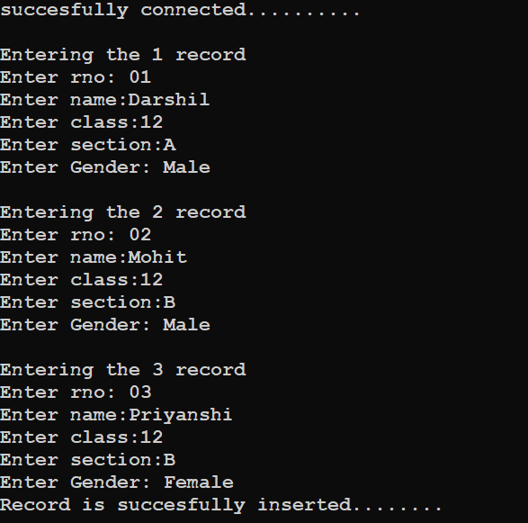

QUES:- Define a function named as update() to update the records of the students taken from user of table class_12 in database school.

PROGRAM:-
import mysql.connector as c
con=c.connect(host='localhost',user='root',password='',database='school',charset='utf8')
if con.is_connected():
print('succesfully connected..........')
cursor=con.cursor()
def update():
rno=int(input('Enter roll number:'))
cursor.execute('desc class_12')
recs=cursor.fetchall()
print(recs[0][0].ljust(8),recs[1][0].ljust(20),recs[2][0].ljust(10),recs[3][0].ljust(10),recs[4][0].ljust(10),sep='')
cursor.execute('select * from class_12 where rno={}'.format(rno))
w=cursor.fetchall()
for rec in w:
print(str(rec[0]).ljust(8),rec[1].ljust(20),str(rec[2]).ljust(10),rec[3].ljust(10),rec[4].ljust(10),sep='')
print('''
1)Name
2)Class
3)Gender
4)Section''')
print()
ch=int(input('Enter Here:'))
if ch==1:
name=input('Enter new name :')
cursor.execute('update class_12 set name="%s" where rno=%d'%(name,rno))
con.commit()
print('Record updated........')
elif ch==2:
clas=int(input('Enter new class :'))
cursor.execute('update class_12 set class=%d where rno=%d'%(clas,rno))
con.commit()
print('Record updated........')
elif ch==3:
gender=input('Enter the new Gender :')
cursor.execute('update class_12 set gender="%s" where rno=%d'%(gender,rno))
con.commit()
print('Record updated.........')
elif ch==4:
sec=input('Enter new Section :')
cursor.execute('update class_12 set sec="%s" where rno=%d'%(sec,rno))
con.commit()
print('Record updated........')
else:
print('WRONG CHOICE !!!!!!!!')
con.close()
update()

OUTPUT:-

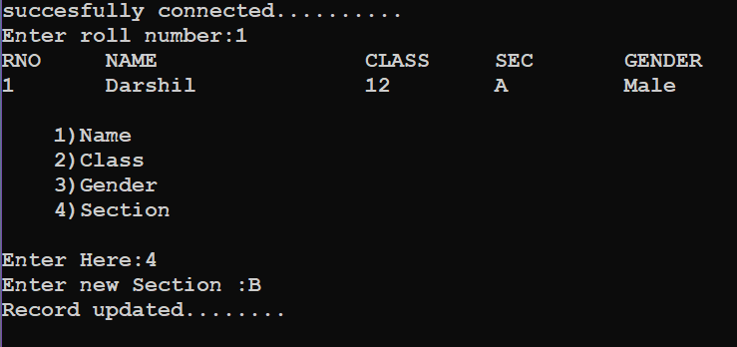
QUES:- Define a function del() to delete the records of the table class_12 of database school.

PROGRAM:-

import mysql.connector as c
con=c.connect(host='localhost',user='root',password='',database='school',charset='utf8')
if con.is_connected():
print('succesfully connected..........')
cursor=con.cursor()

def delete():
while True:
print('''
1)Delete all
2)Delete with Rno''')
ch=int(input("Enter Choice:"))
if ch==1:
que='Delete from class_12'
cursor.execute(que)
elif ch==2:
rn=int(input('Enter Roll number: '))
query='delete from class_12 where rno={}'.format(rn)
cursor.execute(query)
else:
print('WRONG CHOICE.....')
con.commit()
print('Record deleted ...........')
delete()
OUTPUT:-

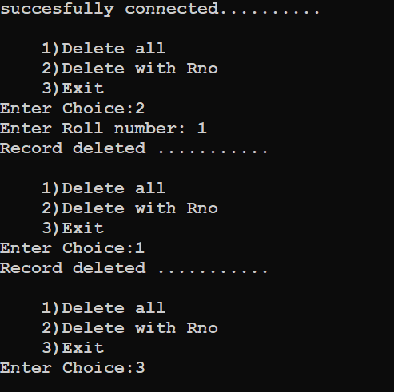

QUES:- Define a function display() to display all the records of the table class_12 of database school.

PROGRAM:-

import mysql.connector as c
con=c.connect(host='localhost',user='root',password='',database='school',charset='utf8')
if con.is_connected():
print('succesfully connected..........')
cursor=con.cursor()

def display():
try:
cursor.execute('desc class_12')
recs=cursor.fetchall()
print(recs[0][0].ljust(6),recs[1][0].ljust(15),recs[2][0].ljust(10),recs[3][0].ljust(10),recs[4][0].ljust(10),\
sep='')
Que='select * from class_12'
cursor.execute(Que)
w=cursor.fetchall()
for rec in w:
print(str(rec[0]).ljust(8),rec[1].ljust(20),str(rec[2]).ljust(10),rec[3].ljust(10),rec[4].ljust(10),sep='')
except Exception as error:
print('Error :- ',error)

display()

OUTPUT:-

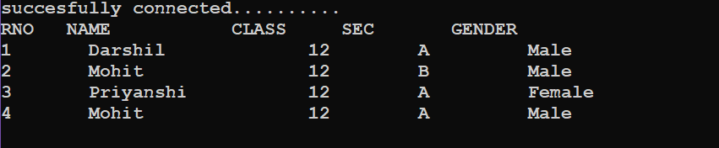

QUES:- Write a python program to display the records of the student of sec A of table class_12 in database school.

PROGRAM:-

import mysql.connector as c
con=c.connect(host='localhost',user='root',password='',database='school',charset='utf8')
if con.is_connected():
print('succesfully connected..........')
cursor=con.cursor()
print()
print('Records of the student of section A :- ')
print()
cursor.execute('desc class_12')
recs=cursor.fetchall()
print(recs[0][0].ljust(6),recs[1][0].ljust(15),recs[2][0].ljust(10),recs[3][0].ljust(10),recs[4][0].ljust(10),\
sep='')
que='select * from class_12 where sec="A" '
cursor.execute(que)
dat=cursor.fetchall()
for rec in dat:
print(str(rec[0]).ljust(8),rec[1].ljust(20),str(rec[2]).ljust(10),rec[3].ljust(10),rec[4].ljust(10),sep='')

dat=cursor.fetchall()

OUTPUT:-

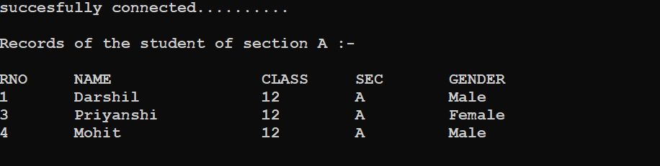

QUES:- Write a python program to delete the records of the students of sec A from table class_12 in database school and then display the content of the table .

PROGRAM:-

import mysql.connector as c
con=c.connect(host='localhost',user='root',password='',database='school',charset='utf8')
if con.is_connected():
print('succesfully connected..........')
cursor=con.cursor()
print()
que='delete from class_12 where sec="A" '
cursor.execute(que)
con.commit()
cursor.execute('desc class_12')
recs=cursor.fetchall()
print(recs[0][0].ljust(6),recs[1][0].ljust(20),recs[2][0].ljust(10),recs[3][0].ljust(10),recs[4][0].ljust(10),sep='')
que='select * from class_12 '
cursor.execute(que)
dat=cursor.fetchall()
for rec in dat:
print(str(rec[0]).ljust(6),rec[1].ljust(20),str(rec[2]).ljust(10),rec[3].ljust(10),rec[4].ljust(10),sep='')
OUTPUT:-

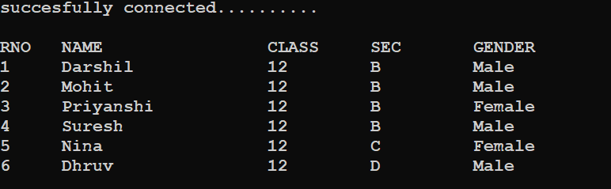

QUES:- Write a python program that display the first three rows fetched from class_12 table of MYSQL database school.

PROGRAM:-

import mysql.connector as c
con=c.connect(host='localhost',user='root',password='',database='school',charset='utf8')
if con.is_connected():
print('succesfully connected..........')
crsr=con.cursor()
print()
crsr.execute('desc class_12')
recs=crsr.fetchall()
print(recs[0][0].ljust(6),recs[1][0].ljust(20),recs[2][0].ljust(10),recs[3][0].ljust(10),recs[4][0].ljust(10),sep='')
que='select * from class_12 '
crsr.execute(que)
dat=crsr.fetchmany(3)
for rec in dat:
print(str(rec[0]).ljust(6),rec[1].ljust(20),str(rec[2]).ljust(10),rec[3].ljust(10),rec[4].ljust(10),sep='')
con.close()
OUTPUT:-

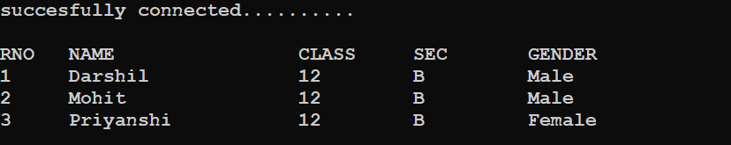

Ques:- Write a python program that deletes records from class_12 table of database school that have gender male and then display the contents of the table.

PROGRAM:-

import mysql.connector as c
con=c.connect(host='localhost',user='root',password='',database='school',charset='utf8')
if con.is_connected():
print('succesfully connected')
cursor=con.cursor()
que='delete from class_12 where gender="Male" '
cursor.execute(que)
con.commit()
print('DISPLAYING THE RECORDS……')
print()
cursor.execute('desc class_12')
recs=cursor.fetchall()
print(recs[0][0].ljust(8),recs[1][0].ljust(20),recs[2][0].ljust(10),recs[3][0].ljust(10),recs[4][0].ljust(10),sep='')
Que='select * from class_12'
cursor.execute(Que)
w=cursor.fetchall()
for rec in w:
print(str(rec[0]).ljust(8),rec[1].ljust(20),str(rec[2]).ljust(10),rec[3].ljust(10),rec[4].ljust(10),sep='')
OUTPUT:-

